Step 1:

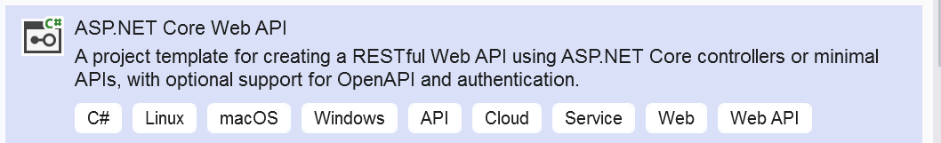
Step 2:
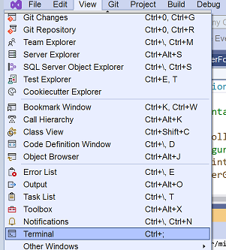

https://medium.com/@ravipatel.it/a-beginners-guide-to-entity-framework-core-ef-core-5cde48fc7f7a

Step 3:
From terminal (CLI):
dotnet new console -n EFCoreInterview //create a new project
cd EFCoreInterview
dotnet add package Microsoft.EntityFrameworkCore
dotnet add package Microsoft.EntityFrameworkCore.SqlServer
Now:
create a C# class to represent the data
For this example, we’ll create a Student class:
Student.cs
namespace EFCoreExample
{
public class Student
{
public int Id { get; set; } ;//you need ID anyway
public string Name { get; set; }
public int Age { get; set; }
}
}

Create a DbContext (auto – you don't need create DB in SQLServer it's created alone)

AppDbContext.cs
using Microsoft.EntityFrameworkCore;
namespace EFCoreExample
{
public class AppDbContext : DbContext
{
public DbSet<Student> Students { get; set; }//this is name of the table
protected override void OnConfiguring(DbContextOptionsBuilder optionsBuilder)
{
optionsBuilder.UseSqlServer(@"Server= (local);Database=EFCoreExampleDB;Trusted_Connection=True; TrustServerCertificate=True ");
}
}
}

Note also can: Server= (localdb)\mssqllocaldb or example's connectionString
connectionString="metadata=res://*/CME.csdl|res://*/CME.ssdl|res://*/CME.msl;provider=System.Data.SqlClient;provider connection string=&quot;data source=nameOfServer;initial catalog=CME.Form_Dev;persist security info=True;user id=sa;password=abcd;MultipleActiveResultSets=True;App=EntityFramework&quot;"

Program.cs
using Microsoft.EntityFrameworkCore;
using WebApplication1.Models;

var builder = WebApplication.CreateBuilder(args);
//DI for DbContext
builder.Services.AddDbContext<WeatherForecastDBContext>(options =>
options.UseSqlServer(@"Server= (local);Database=EFCoreExampleDB;Trusted_Connection=True; TrustServerCertificate=True "));
// Add services to the container.

builder.Services.AddControllers();
// Learn more about configuring OpenAPI at https://aka.ms/aspnet/openapi
builder.Services.AddOpenApi();

var app = builder.Build();

// Configure the HTTP request pipeline.
if (app.Environment.IsDevelopment())
{
app.MapOpenApi();
}

app.UseHttpsRedirection();

app.UseAuthorization();

app.MapControllers();

app.Run();

Next step:
dotnet add package Microsoft.EntityFrameworkCore.Tools
dotnet ef migrations add InitialCreate
dotnet ef database update

Next step:
dotnet run
open site :
https://localhost:44302/weatherforecast

Very important!
Migrations allow you to update your database schema as your model changes.
We save all history of migrations so we write something like that:
because we add new field in student model that his name Timestamp
after that we write in CLI
dotnet ef migrations add AddStudentCreatedTimestamp
dotnet ef database update

Queries:
// Adding a new student
var student = new Student { Name = "John Doe", Age = 20 };
context.Students.Add(student);
context.SaveChanges();

// Querying the student (get from DB)
var query = context.Students.Where(s => s.Name == "John Doe");

foreach (var stud in query)
{
Console.WriteLine($"Student: {stud.Name}, Age: {stud.Age}");
}

Updating Data

var student = context.Students.First(s => s.Name == "Alice");
student.Age = 23;
context.SaveChanges();

Deleting Data
var student = context.Students.First(s => s.Name == "Alice");
context.Students.Remove(student);
context.SaveChanges();

Get all students:
var students = context.Students.ToList();

Filter students by age:
var students = context.Students.Where(s => s.Age > 20).ToList();

Get a single student by ID:
var student = context.Students.Find(1);

controller:

using Microsoft.AspNetCore.Mvc;
using WebApplication1.Models;

namespace WebApplication1.Controllers
{

[ApiController]
[Route("[controller]")] //or if you want [Route("api/GetWeatherForecast")]
public class WeatherForecastController : Controller
{
private static readonly string[] Summaries = new[]
{
"Freezing", "Bracing", "Chilly", "Cool", "Mild", "Warm", "Balmy", "Hot", "Sweltering", "Scorching"
};

private readonly WeatherForecastDBContext _context;
public WeatherForecastController(WeatherForecastDBContext context)
{
_context = context;
}

[HttpGet("/bb/{id:int}")] // GET /bb/2
public IEnumerable<WeatherForecast> Get2(int id)
{
Console.WriteLine("test{0}", id);

_context.wf.Add(new WeatherForecast
{
Date = DateOnly.FromDateTime(DateTime.Now.AddDays(5)),
TemperatureC = Random.Shared.Next(-20, 55),
Summary = Summaries[Random.Shared.Next(Summaries.Length)]
});
_context.SaveChanges();
Console.WriteLine("test2");
return Enumerable.Range(1, 5).Select(index => new WeatherForecast
{
Date = DateOnly.FromDateTime(DateTime.Now.AddDays(index)),
TemperatureC = Random.Shared.Next(-20, 55),
Summary = Summaries[Random.Shared.Next(Summaries.Length)]
})
.ToArray();
}

[HttpGet(Name = "GetWeatherForecast")]
public IEnumerable<WeatherForecast> Get()
{

_context.wf.Add(new WeatherForecast {
Date = DateOnly.FromDateTime(DateTime.Now.AddDays(5)),
TemperatureC = Random.Shared.Next(-20, 55),
Summary = Summaries[Random.Shared.Next(Summaries.Length)]
});
_context.SaveChanges();
Console.WriteLine("test");
return Enumerable.Range(1, 5).Select(index => new WeatherForecast
{
Date = DateOnly.FromDateTime(DateTime.Now.AddDays(index)),
TemperatureC = Random.Shared.Next(-20, 55),
Summary = Summaries[Random.Shared.Next(Summaries.Length)]
})
.ToArray();

}

// DELETE: api/DCandidate/5
[HttpDelete("{id}")]
public async Task<ActionResult<WeatherForecast>> DeleteDCandidate(int id)
{
var dCandidate = await _context.wf.FindAsync(id);
if (dCandidate == null)
{
return NotFound();
}

_context.wf.Remove(dCandidate);
await _context.SaveChangesAsync();

return dCandidate;

}

// POST: api/DCandidate
// To protect from overposting attacks, please enable the specific properties you want to bind to, for
// more details see https://aka.ms/RazorPagesCRUD.
[HttpPost]
public async Task<ActionResult<WeatherForecast>> PostDCandidate(WeatherForecast dCandidate)
{
_context.wf.Add(dCandidate);
await _context.SaveChangesAsync();

return CreatedAtAction("GetDCandidate", new { id = dCandidate.Id }, dCandidate);
}

}
}

Controllers
SalesCustomersController.cs

[Route("api/cities")]
[ApiController]
public class SalesCustomersController : Controller
…
// GET: SalesCustomers/AddOrEdit
[HttpGet("{id}")]
public IActionResult AddOrEdit(int id = 0)
…
// POST: SalesCustomers/AddOrEdit
[HttpPost]
public async Task<IActionResult>

…
// PUT: api/DCandidate/5
[HttpPut("{id}")]
public async Task<IActionResult> PutDCandidate(int id, DCandidate dCandidate)

// DELETE: api/DCandidate/5
[HttpDelete("{id}")]
public async Task<ActionResult<DCandidate>> DeleteDCandidate(int id)

// GET: api/DCandidat/Search
[HttpGet("Search/{name}")]
public async Task<ActionResult<DCandidate>> SearchCity(string name)

